**Lab 3: Uncover New Digital Evidence Using Bootable Forensic Utilities**

**By**

**Natnael Kebede**



**University of Dallas**

**2020**

This Paper Submitted in Partial Fulfillment of the Requirements for

CYBS 7359 – Penetration Testing and Vulnerability Assessment

Spring 2020

Presented to Dr. Renita Murimi

**Section 1**

1. Make a screen capture showing the Network Information data from the System Information screen and paste it into your Lab Report file.

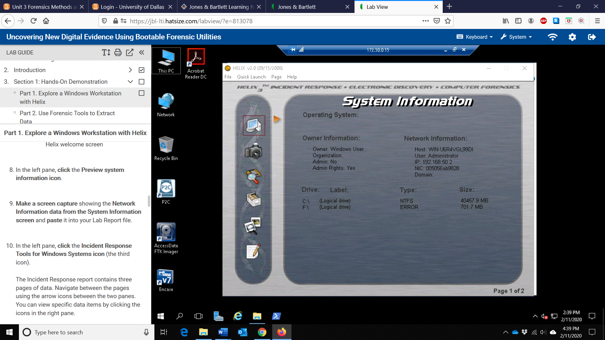

1. Make a screen capture showing the PC on/off Time window and paste it into the Lab Report file.

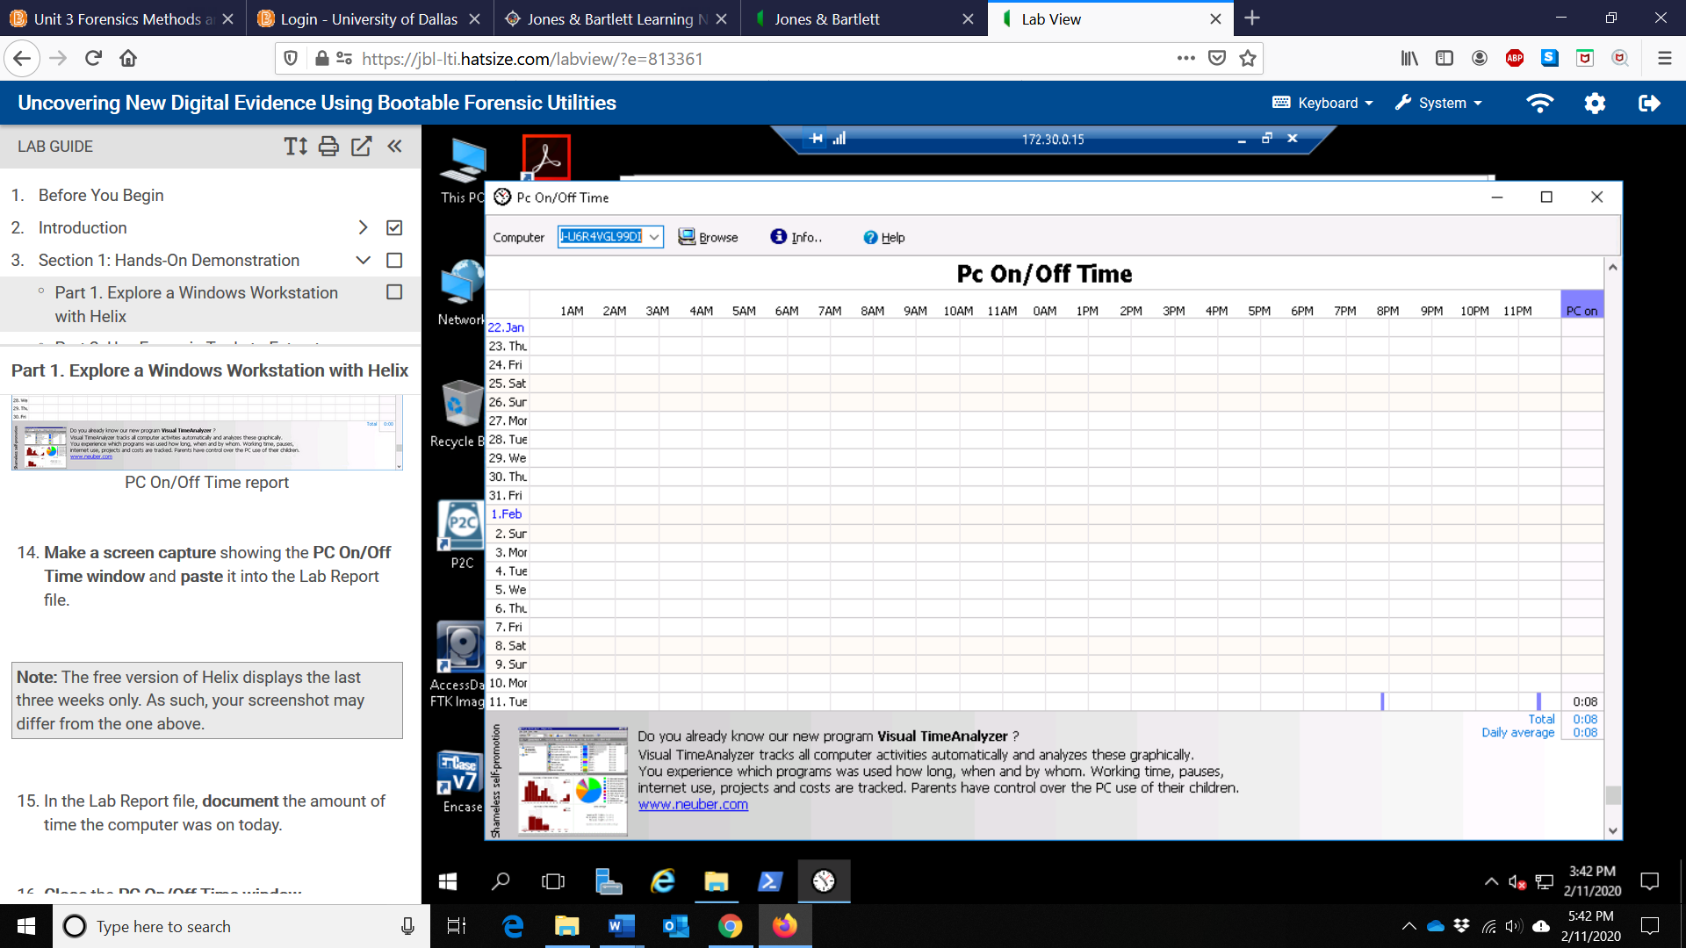

1. In the Lab Report file, document the amount of time the computer was on today

**0 hours and 8 minutes**

1. In the Lab Report file, document the following data as displayed at the bottom of the Helix window:

File name: **TravelPhoto.bmp**

File size: **3164x2112**

Color depth: **24bit**

1. Make a screen capture showing the Details tab of the Properties dialog box and paste it into the Lab Report file.

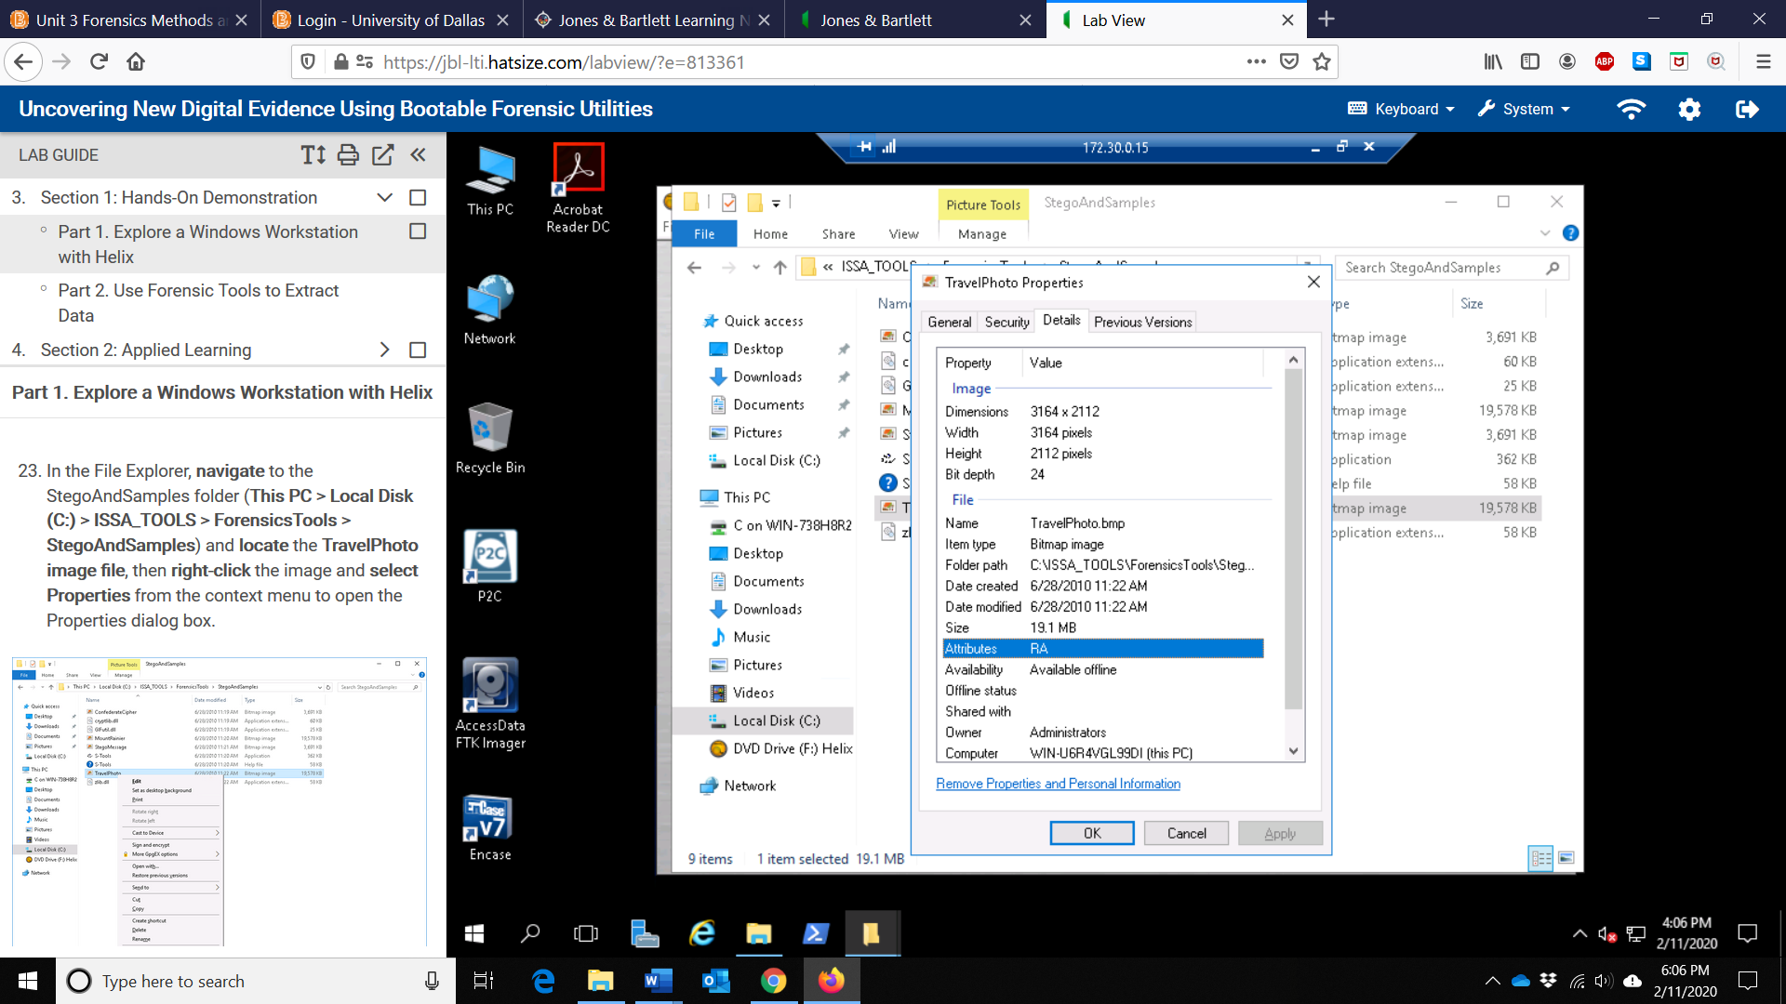

1. Make a screen capture showing the image and paste it into the Lab Report file.

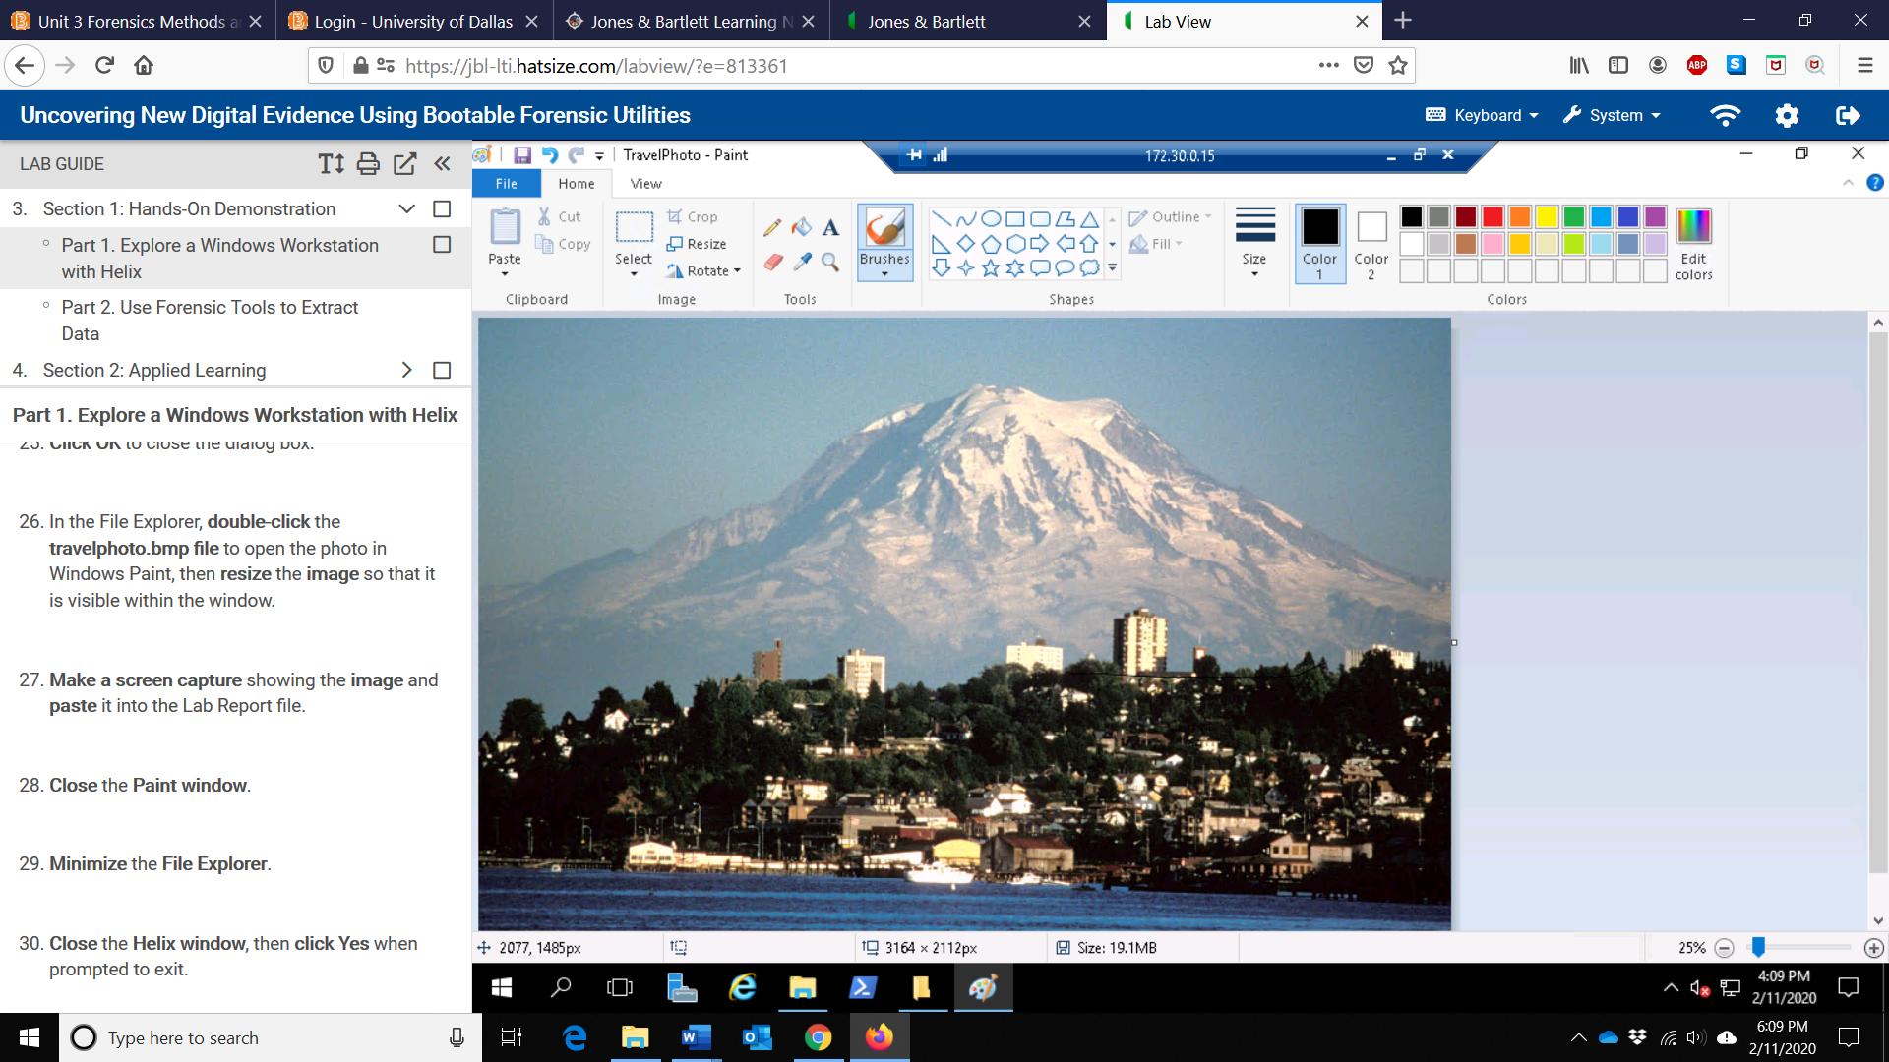

1. Make a screen capture showing the Process Explorer window and the highlighted item and paste it into the Lab Report file.

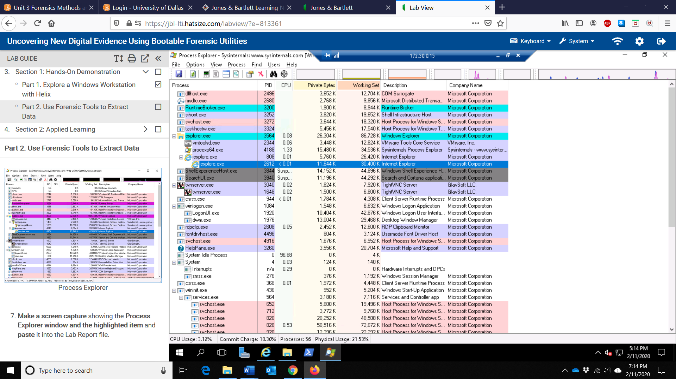

1. In the Lab Report file, document the memory value from the Private Bytes column:

**11,644k**

1. Make a screen capture showing the FavoritesView window and the highlighted item and paste it into the Lab Report file.

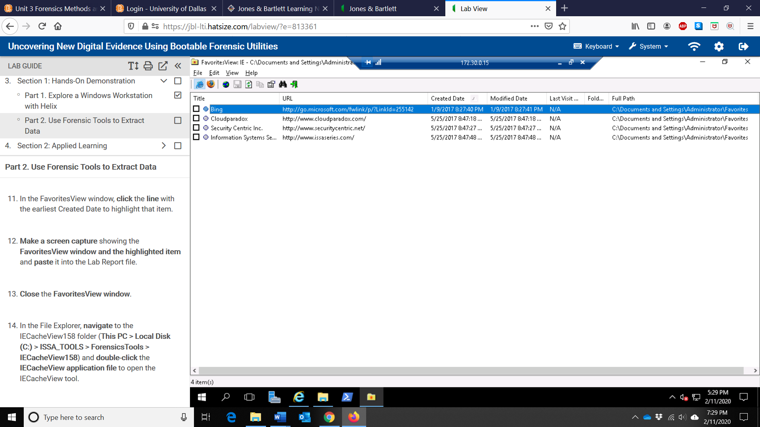

1. Make a screen capture showing the IECacheView window and the highlighted item and paste it into the Lab Report file.

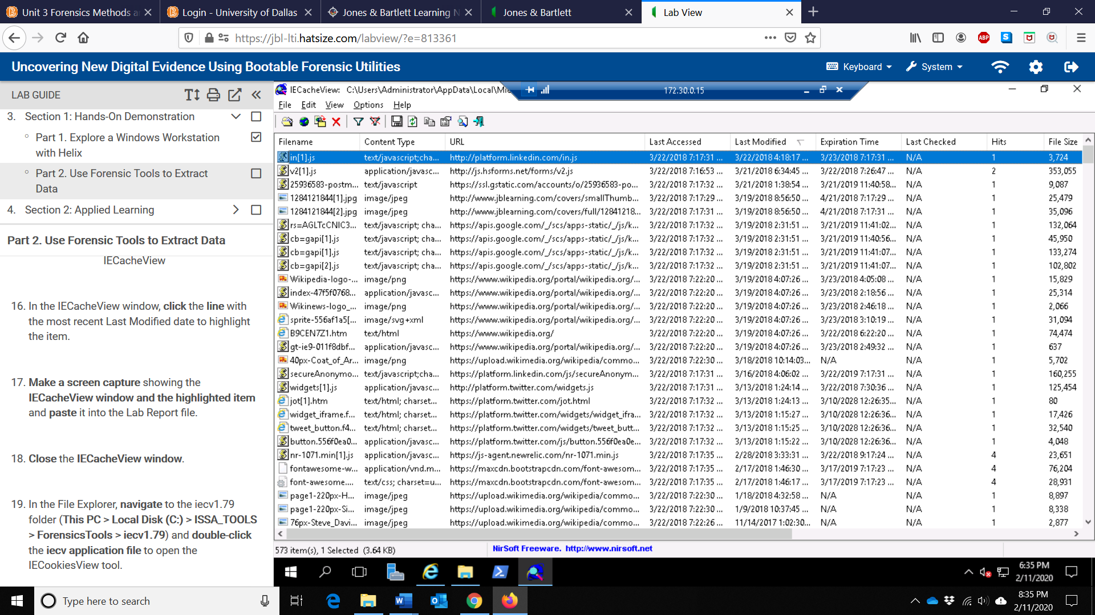

1. Make a screen capture showing the IECookiesView window and the highlighted item and paste it into the Lab Report file.

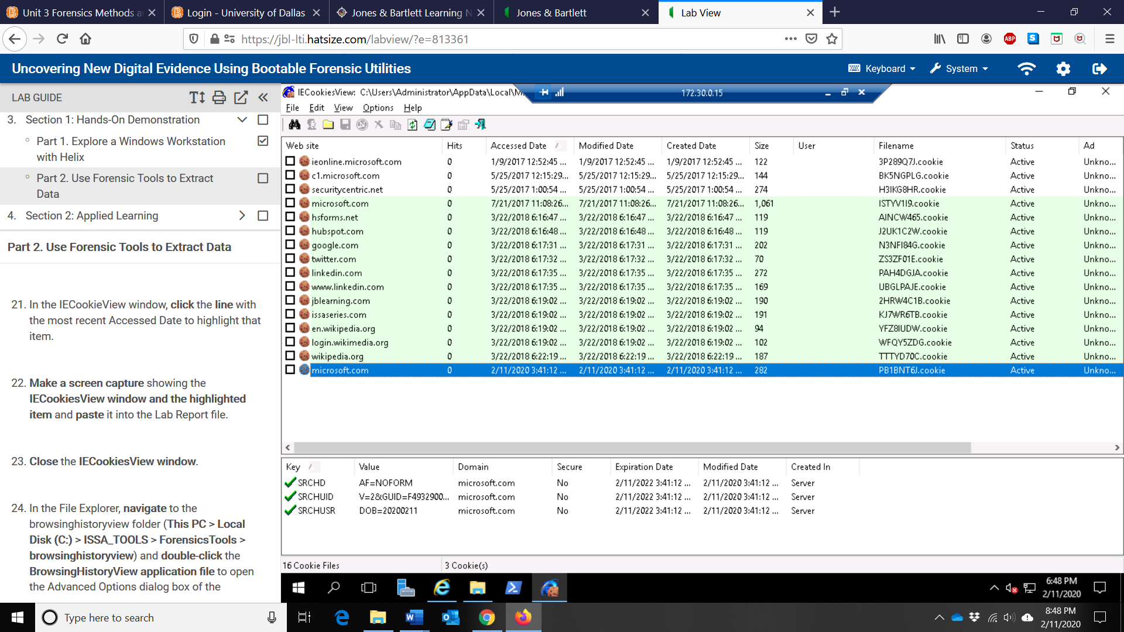

1. Make a screen capture showing the BrowsingHistoryView window and the highlighted item and paste it into the Lab Report file.

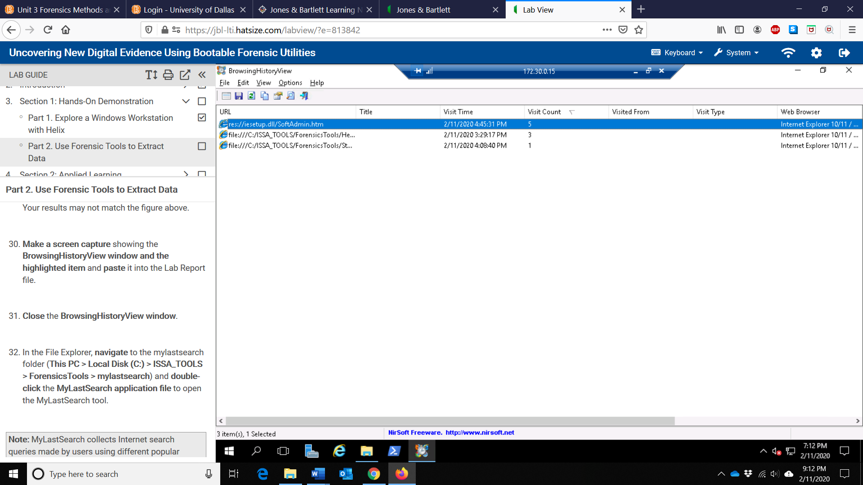

1. Make a screen capture showing the MyLastSearch window with the highlighted item and paste into your Lab Report file.

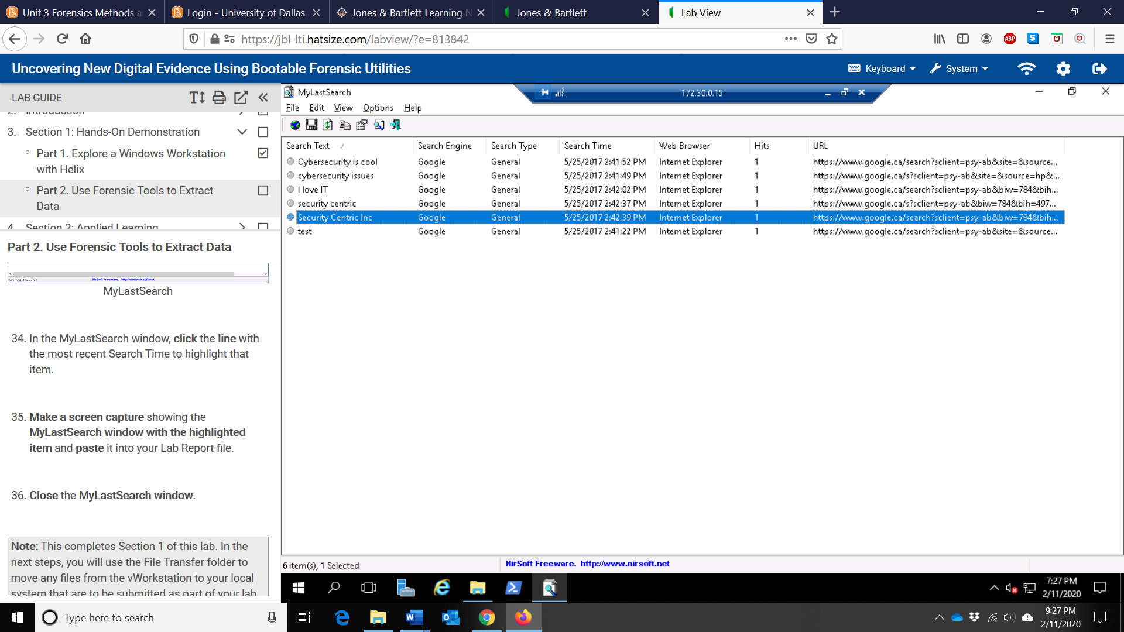

Deliverables:

1. Files downloaded from the virtual environment:

**Kebede_S1_HelixAudit.pdf**

1. Any additional information as directed by the lab:

a. The amount of time the computer was on today; **0 hour and 8 minutes**

b. Helix data points associated with TravelPhoto.bmp;

File name: **TravelPhoto.bmp**

File size: **3164x2112**

Color depth: **24bit**

c. The memory value from the Private Bytes column of Process Explorer; **11,644 K**